N대1 양방향 실습

* 스프링 부트, 마리아DB를 사용하여 N:1 관계 양방향 예제를 작성해보자.

<http://ojc.asia/bbs/board.php?bo_table=LecSpring&wr_id=524>

(마리아 DB 설치는 위 URL에서 참조)

STS -> Spring Starter Project

Name : manytoone

Type : Maven

Package : demo

다음 창에서 SQL -> JPA, MySQL 선택

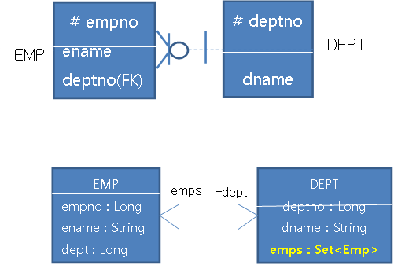

**application.properties**

spring.datasource.platform=mysql

spring.datasource.url=jdbc:mysql://localhost/manytoone?createDatabaseIfNotExist=true

spring.datasource.username=root

spring.datasource.password=1111

spring.datasource.driver-class-name=com.mysql.jdbc.Driver

spring.datasource.sql-script-encoding=UTF-8

spring.jpa.hibernate.ddl-auto=create

spring.jpa.show-sql=true

**Dept.java(도메인 오브젝트)**

**package demo.model;**

@Entity

@Table(name = "dept")

public class Dept {

private Long deptno;

private String dname;

private Set<Emp> emps;

public Dept() { }

public Dept(String dname) {

this.dname = dname;

}

public Dept(String dname, Set<Emp> emps) {

this.dname = dname;

this.emps = emps;

}

@Id

@GeneratedValue

public Long getDeptno() { return deptno; }

public void setDeptno(Long deptno) {

this.deptno = deptno;

}

public String getDname() { return dname; }

public void setDname(String dname) {

this.dname = dname;

}

**//Emp 엔티티의 dept 속성(필드)를 매핑**

**//mappedBy에서 반대쪽(many쪽),Owner가 되는 쪽의 매핑되는 속성지정**

**@OneToMany(mappedBy = "dept", cascade = CascadeType.ALL)**

public Set<Emp> getEmps() { return emps; }

public void setEmps(Set<Emp> emps) {

this.emps = emps; }

public String toString() {

String s = String.format("DEPT[deptno = %d, dname = '%s']%n", deptno, dname);

if (emps != null) {

for(Emp e : emps) {

s += String.format("EMP[empno = %d, ename = '%s', deptno = '%s']%n",

e.getEmpno(), e.getEname(),

e.getDept()==null?"":e.getDept().deptno);

}

}

return s;

}

}

만약 위 예문에서 List를 이용한다면 아래와 같다.

**@OneToMany(mappedBy=“dept”, cascade=CascadeTYpe.ALL)**

**@OrderBy(“dname DESC”)**

**@OrderColumn(name=“emp_index”)**

private **List**<Emp> emps;

**🡺 EMP테이블에 emp_index 칼럼이 자동 생성된다.**

**Emp.java**

**package demo.model;**

@Entity

@Table(name = "emp")

public class Emp {

private Long empno;

private String ename;

private Dept dept;

public Emp() {}

public Emp(String ename) {

this.ename = ename;

}

public Emp(String ename, Dept dept) {

this.ename = ename;

this.dept = dept;

}

@Id

@GeneratedValue

public Long getEmpno() {

return empno;

}

public void setEmpno(Long empno) {

this.empno = empno;

}

public String getEname() {

return ename;

}

public void setEname(String ename) {

this.ename = ename;

}

**@ManyToOne**

**//deptno는 현재 엔티티 테이블의 조인칼럼명**

**//생략시 조인칼럼명은 dept_deptno가 된다.**

**@JoinColumn(name="deptno")**

public Dept getDept() {

return dept;

}

public void setDept(Dept dept) {

this.dept = dept;

}

public String toString() {

String s = String.format("EMP[empno = %d, ename = '%s', deptno=%d]%n", empno, ename, getDept().getDeptno());

return s;

}

}

**DeptRepository.java(레포지토리 클래스)**

**package demo.repository;**

import org.springframework.data.jpa.repository.JpaRepository;

import demo.model.Dept;

public interface DeptRepository extends JpaRepository<Dept, Long> { }

**ManyTooneApplication.java(스프링부트 메인)**

**package demo;**

import java.util.HashSet;

import java.util.Set;

import javax.transaction.Transactional;

import org.slf4j.Logger;

import org.slf4j.LoggerFactory;

import org.springframework.beans.factory.annotation.Autowired;

import org.springframework.boot.CommandLineRunner;

import org.springframework.boot.SpringApplication;

import org.springframework.boot.autoconfigure.SpringBootApplication;

import demo.model.Dept;

import demo.model.Emp;

import demo.repository.DeptRepository;

**@SpringBootApplication**

public class ManytooneApplication implements CommandLineRunner {

private static final Logger logger = LoggerFactory.getLogger(ManytooneApplication.class);

@Autowired

private DeptRepository deptRepository;

public static void main(String[] args) {

SpringApplication.run(ManytooneApplication.class, args);

}

**//아래에서 @Transactional이 생략되면 org.hibernate.LazyInitializationException: failed to lazily initialize a collection of role: demo.model.Dept.emps, could not initialize proxy 오류발생**

@Override

**@Transactional**

public void run(String...strings) throws Exception {

**//Dept에 1번부서가 만들어지고, Emp의 deptno는 1로 입력됨**

Dept d1 = new Dept("교육팀");

Emp e1 = new Emp("김교육", d1);

Emp e2 = new Emp("나교육", d1);

d1.setEmps(new HashSet<Emp>() {

{

add(e1);

add(e2);

}

});

**//Dept에 2번 부서가 만들어지고 Emp의 deptno는 NULL로 입력**

Dept d2 = new Dept("개발팀", new HashSet<Emp>() {

{

add(new Emp("김개발"));

add(new Emp("나개발"));

}

});

**//Dept, Emp 저장**

deptRepository.save(new HashSet<Dept>() {

{

add(d1);

add(d2);

}

});

for(Dept d : deptRepository.findAll()) {

logger.info(d.toString());

}

**//------------- 1번 부서 및 부서원 로드**

Dept d3 = deptRepository.findOne(1L);

Set<Emp> emps = d3.getEmps();

for(Emp e : emps) {

logger.info(e.toString());

}

**//------------- 1번부서 삭제, 1번부서원들도 같이 삭제된다.**

deptRepository.delete(d3); }

}

}

**데이터 확인하기**

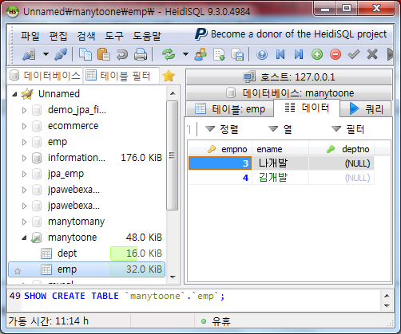

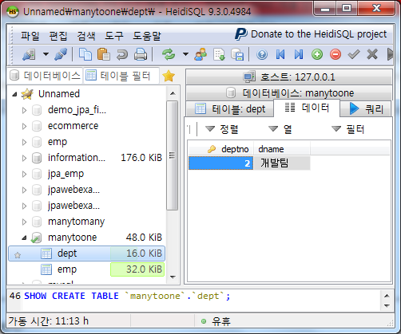

**[DB쪽 생성 스크립트 및 결과**]

Hibernate: alter table emp drop foreign key FK_gbxl70x5ckxun8hi19v4n6dfb

Hibernate: drop table if exists dept

Hibernate: drop table if exists emp

Hibernate: create table dept (deptno bigint not null auto_increment, dname varchar(255), primary key (deptno))

Hibernate: create table emp (empno bigint not null auto_increment, ename varchar(255), deptno bigint, primary key (empno))

Hibernate: alter table emp add constraint FK_gbxl70x5ckxun8hi19v4n6dfb foreign key (deptno) references dept (deptno)

Hibernate: insert into dept (dname) values (?)

Hibernate: insert into emp (deptno, ename) values (?, ?)

Hibernate: insert into emp (deptno, ename) values (?, ?)

Hibernate: insert into dept (dname) values (?)

Hibernate: insert into emp (deptno, ename) values (?, ?)

Hibernate: insert into emp (deptno, ename) values (?, ?)

Hibernate: select dept0_.deptno as deptno1_0_, dept0_.dname as dname2_0_ from dept dept0_

**//메인 출력**

**DEPT[deptno = 1, dname = '교육팀']**

**EMP[empno = 1, ename = '김교육', deptno = '1']**

**EMP[empno = 2, ename = '나교육', deptno = '1']**

**DEPT[deptno = 2, dname = '개발팀']**

**EMP[empno = 3, ename = '나개발', deptno = '']**

**EMP[empno = 4, ename = '김개발', deptno = '']**

**EMP[empno = 1, ename = '김교육', deptno=1]**

**EMP[empno = 2, ename = '나교육', deptno=1]**

Hibernate: delete from emp where empno=?

Hibernate: delete from emp where empno=?

Hibernate: delete from dept where deptno=?